7.60: a) The change in total energy is the work done by the air,
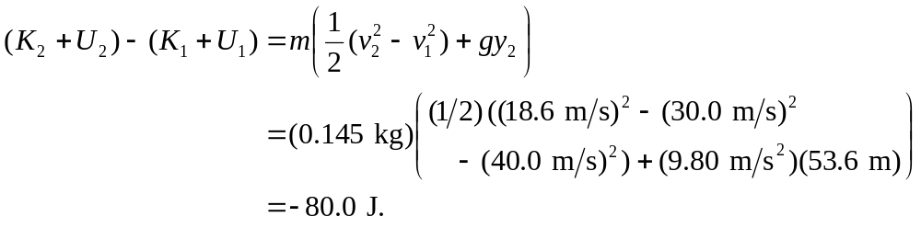

b) Similarly,

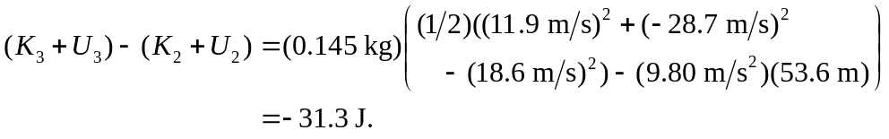

c) The ball is moving slower on the way down, and does not go as far (in the x-direction), and so the work done by the air is smaller in magnitude.

